

Not surprisingly, having operated steam railway tours in many different countries of the world for more than 45 years, we have amassed a collection of film and video material largely unsurpassed in the UK. Many people have told us that we should make this generally available, since most of it is unrepeatable, and so we have put together some of our best material, mainly taken on Enthusiast Holidays tours, and edited onto DVD (and Blu-Ray). Our first titles are shown here, but others will follow. Each one is available for £16 including p+p within the UK, on Bly-Ray or ordinary DVD (please specify). Payment by Mastercard/Visa/American Express, or by cheque to Enthusiast Holidays, or by PayPal to info@enthusiasthols.com.

In the late 1990’s and early 2000’s many British steam enthusiasts headed for Cuba, to witness the “Zafra” – the annual sugar harvest which ran roughly from Christmas to Easter, and saw many American steam locos. brought back into action, to bring the sugar cane from the fields into the mills, or “Centrales”, for processing.
Sadly the break-up of the Soviet Union – Cuba’s main market – put an end to these workings, so this 1½ hour documentary is a memento of some of the most spectacular sights of those halcyon years.

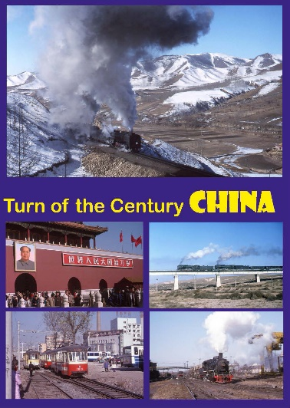
At around the same time, on the other side of the world, steam was enjoying its final triumph in a climate very different from the tropical sunshine of Cuba – in freezing temperatures, we would head for the Jingpeng Pass, and other locations in Inner Mongolia (in China) to witness double-headed 2-10-2’s with mineral trains; or the ubiquitous “SY” 2-8-2’s in steelworks like Anshan; or on passenger trains in the coal mining area of Tiefa – or “JS” 2-8-2’s struggling out of the open-cast coal pit at Sandaoling – the latter two we hope to be able to repeat next year, by the way! Chinese n.g. lines are also featured in this 2hr 25 min feast of Chinese steam!

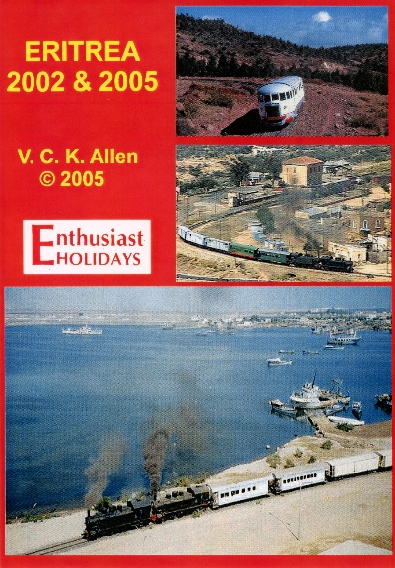
Enthusiast Holidays was the first UK tour operator to visit Eritrea, where pre-war Italian Mallets – carefully stored since the war with Ethiopia in 1975 – started to run again between the capital, Asmara, and the Red Sea port of Asmara.
Our first trip, in 2002, had to be run in two parts, as there was a gap of some 32kms in the most spectacular section through the mountains of this 117km line – by 2005 the railway was complete, and we travelled by steam train, by “Littorina” railcar, and some of us, perilously, by rail lorry, preceding the steam train so as to film it for this 1hr 15min documentary!
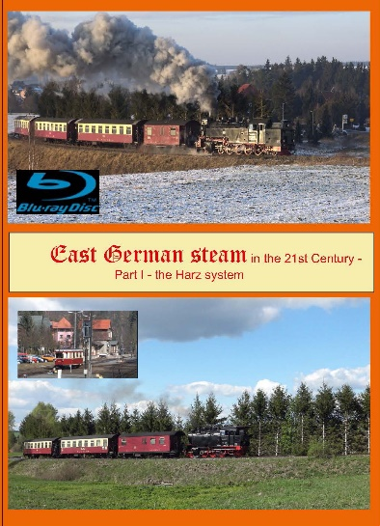
The former East Germany had many narrow gauge steam railways, many of which still run today – mainly for tourists, but to an extent to serve t local population.
This 1hr 10min documentary – “Part 1” - covers the largest of these, the Harz system, providing spectacular scenery in summer and winter, including the ride up East Germany’s highest mountain, the Brocken, which was out of bounds during Communist times because of the Soviet listening post at the top! All three parts of the Harz n.g. system are covered.

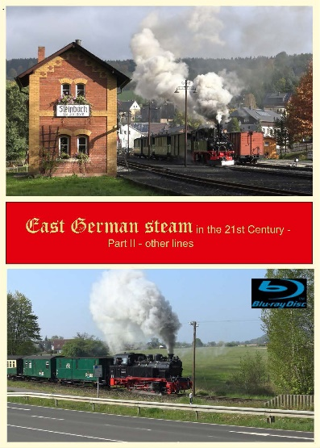
Part 2 of our coverage of the former East German narrow gauge – also 1hr 10mins - takes us to the Baltic coast – to the island of Rugen, and the Mollibahn at Bad Doberan (where we had to fly our drone to film the train with the sea in the background!) to several systems in the South close to the Czech border. Some systems use the delightful Saxon Meyers, like the Oschatz-Mugeln line serving the Meissen porcelain industry, and the Pressnitztalbahn. Larger locos. are seen on the Radebeul line near Dresden, on the mountainous Cranztal – Oberwiesental line, and Zittau – Oybin, and the line to Kipsdorf (re-opened after flooding).
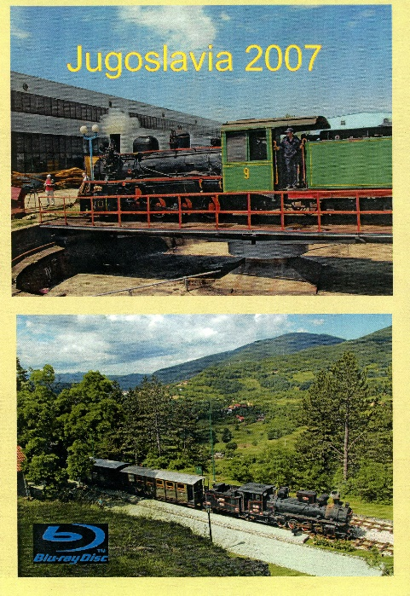
During the Communist period, railway enthusiasts travelled in, and photographed trains in Jugoslavia at their peril! Arrests and confiscation of film – sometimes quite brutally – were common.
Luckily by our visit in 2007 things had changed, and there was still enough steam around to make our trip worthwhile – mostly, it has to be said, in industrial settings, although we did charter a Serbian “01” 2-6-2 for our special train. A trip on the 76cm gauge Mokra Gora railway in lovely scenery, with an “83” 0-8-2 and other locos., was another delight.

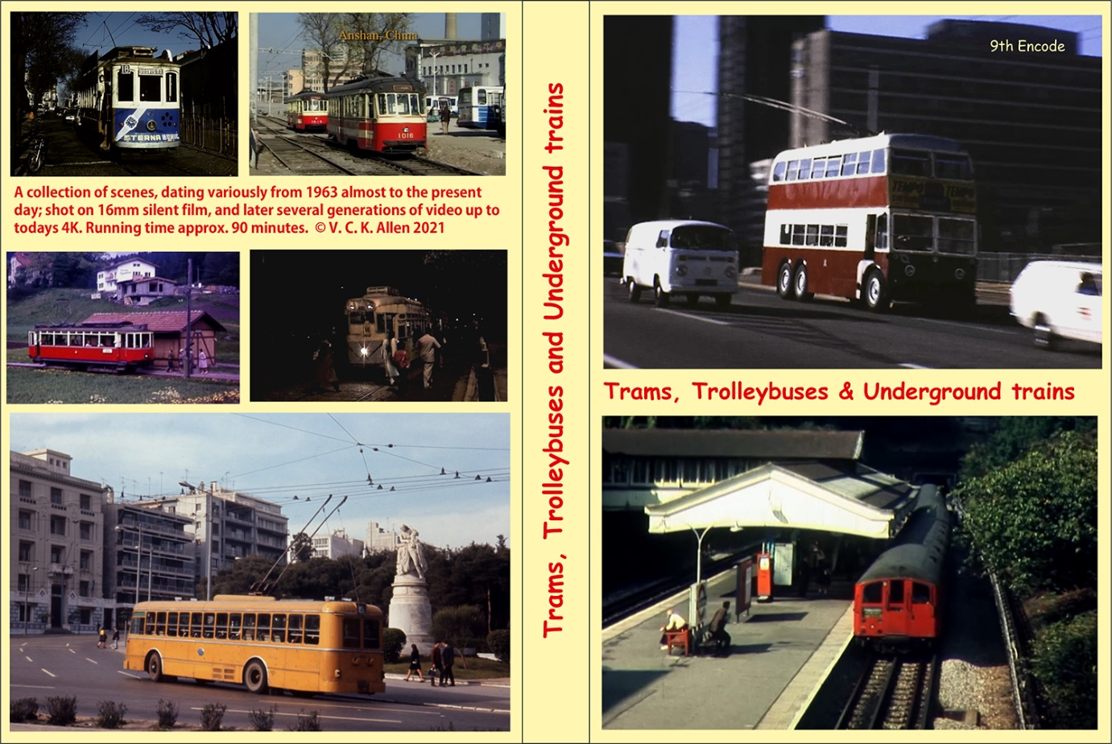

During our travels over 45 or so years in search of steam, it was inevitable that we would come across the odd tram, trolleybus and Underground train – and we photographed and filmed them where we could! Compiled from 16mm silent film, early video from VHS and Hi8 right up to (in one case) 4K, these clips add up to an impressive 90 minutes – including rare footage of the ex-London Transport “Q1” trolleybuses at work in Spain in the late 1970’s

